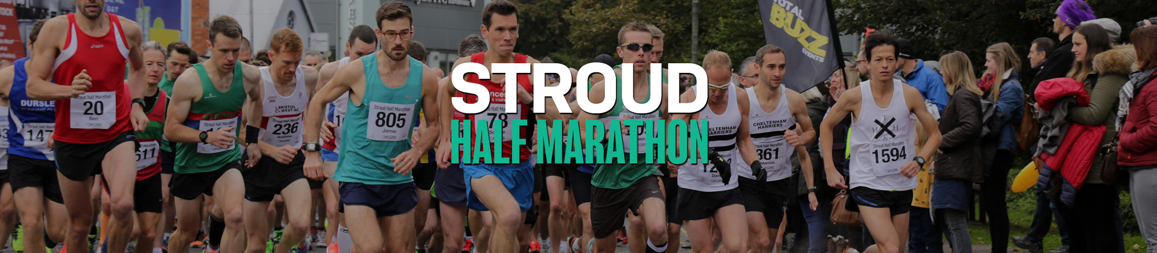

Caerleon Running Club - Results
https://www.fullonsport.com/event/stroud-half-marathon-2017/results/?searchFor=Caerleon

Caerleon Running Club – Mark Alford
https://www.fullonsport.com/event/stroud-half-marathon-2017/results/?searchFor=Hambly

Caerleon Running Club – Morris Urquhart
https://www.fullonsport.com/event/stroud-half-marathon-2017/results/?searchFor=Clive+Richards

