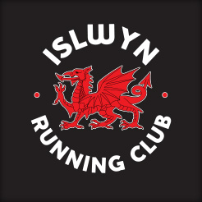

Murder Mile

Matthew Mulcahy 10m 51s
Lloyd Hughes 12m 39s
Gareth Howells 13m 28s
Paul Adams 14m 23s

