Race the Train 2017

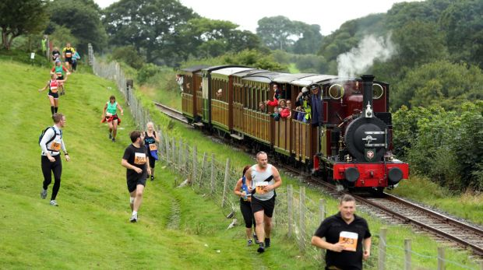

Gwawr Parker 1:16.11

