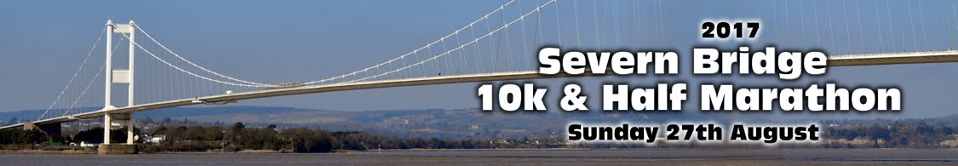

Half Marathon
Paula Williams 1:42:42
Jason Pritchard 1:43:22
Ryan Jones 1:49:23
Pete Burrows 2:10:22
Jane Derrick 2:31:24
Claire Orford 2:31:24

10K
Nicky Lewis 1:08:08
Jo Cornes 1:12:06
Gwawr Parker 1:14:39

